# Lab: Basic Syntax, Conditional Statements and Loops

Problems for in-class lab for the [Python Fundamentals Course @SoftUni](https://softuni.bg/trainings/3003/python-fundamentals-september-2020). Submit your solutions in the SoftUni judge system at <https://judge.softuni.bg/Contests/1718>

## Biggest of Three Numbers

Write a program that receives **three whole numbers** and print the **biggest one**

### Example

|  |  |
| --- | --- |
| **Input** | **Output** |
| 3  -1  5 | 5 |
| 0  -1  -2 | 0 |

### Hints

We start by reading the three numbers from the console:

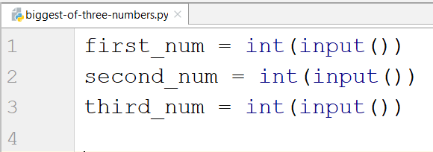

Then we compare them and print the biggest one:

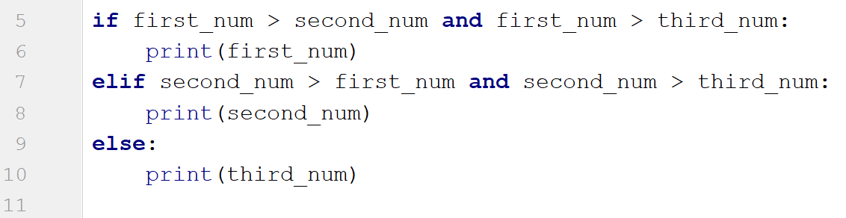

## Number Definer

Write a program that reads a floating-point number and prints **"zero"** if the number is zero. Otherwise, print **"positive"** or **"negative"**. Add **"small"** if the absolute value of the number is less than 1, or **"large"** if it exceeds 1 000 000.

### Example

|  |  |
| --- | --- |
| **Input** | **Output** |
| 25 | positive |
| 0.7 | small positive |
| 435247392.921 | large positive |
| -0.005 | small negative |
| -103.21 | negative |
| -358583355123.001 | large negative |

### Hints

First, we read the number from the console as a float, because we are going to receive floating point numbers:



Then, we write the conditions if the number is zero:

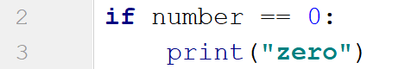

After that, we write the condition if the number is positive and add the additional conditions to that:

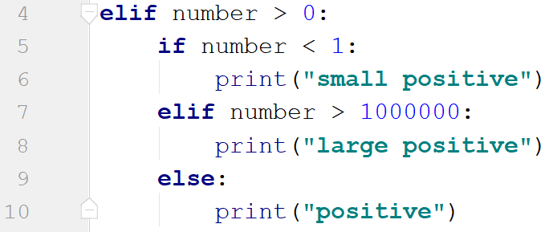

Then, if the number is negative. For the nested conditions here, we use the absolute value of the number, because that is what we need:

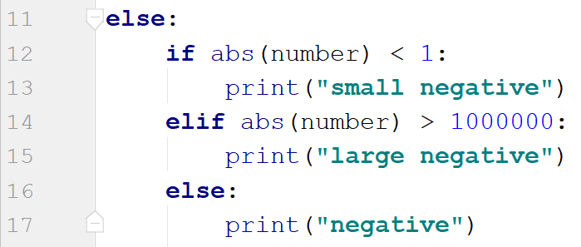

## Word Reverse

Write a program that receives a single word from the user, reverses it and prints it

### Example

|  |  |
| --- | --- |
| **Input** | **Output** |
| Python | nohtyP |
| banana | ananab |

### Hints

We read the word from the console



We create new variable to store the reversed word



We create a reversed loop and add each character to the new word

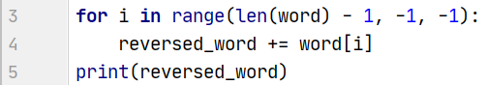

* We start form the length of the word - 1, because indices start from 0
* To loop until we reach 0, we type as end -1, because the end is not inclusive
* Finally the step is negative, so we type -1

## Number Between 1 and 100

Write a program which reads numbers from the console until it receives a number between 1 and 100 inclusive. When the correct number is received, stop reading and print **"The number {number} is between 1 and 100"**

### Example

|  |  |
| --- | --- |
| **Input** | **Output** |
| -3  0.9  44 | The number 44.0 is between 1 and 100 |

### Hints

We start by reading a floating-point number



We create a while loop with a condition for the number being less than 1 or greater than 100, since that is when we want to enter the body of the loop:

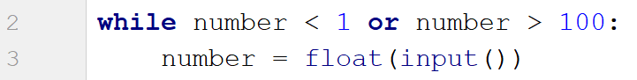

If the condition is not met, we exit the loop and print the result:



## Patterns

Write a program to create the following pattern:

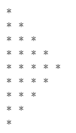

You will receive a number that represents the highest number of stars.

### Example

|  |  |
| --- | --- |
| **Input** | **Output** |
| 3 | *  **  ***  **  * |
| 5 | *  **  ***  ****  *****  ****  ***  **  * |

### Hints

First, we read the number from the console:



We create the first loop, which will print the half of the pattern, until **i == number**:

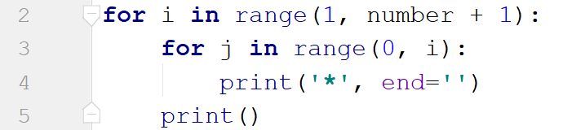

We create the inner loop to loop through the number from **0** to **i** (remember **i** is not inclusive). We use **end=''** to stay on the same line. We print the new line after we draw all the start for the particular line

Now, we create the second loop, which will draw one line less than the previous one (since the count of the lines is always odd):

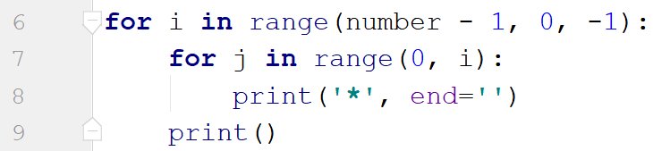

Here we loop backwards, because we decrease the number of stars with each line.